1.a.

Create an XHTML document that defines a table that has two levels of column labels: an overall label ‘Fruit Juices’ and three secondary labels ‘Apple’, ‘Orange’ and ‘Mango’. There must be two levels of row labels: an overall label ‘Meals’ and three secondary labels ‘Breakfast’, ‘Lunch’ and ‘Dinner’. The cells of the table must contain ‘Yes’ or ‘No’.

**1a.html**

<?xml version="1.0" encoding="utf-8"?>

<!DOCTYPE html PUBLIC -"//w3c//DTD XHTML1.1//EN""http://www.w3.org//TR/xhtml/DTD/xhtml.dtd>

<html xmlns="https://www.w3.org/1999/XHTML">

<head><title>Table for Fruit Juices</title></head>

<body>

<table border="5" >

<tr>

<td rowspan="2" colspan="2" > </td>

<th colspan="4" align="center" > Fruit Juices </th>

</tr>

<tr >

<th>Apple</th>

<th>Orange</th>

<th>Pear</th>

</tr>

<tr>

<th rowspan="4"> Meals </th>

</tr>

<tr>

<th>Breakfast</th>

<td>0</td>

<td>1</td>

<td>0</td>

</tr>

<tr>

<th>Lunch</th>

<td>0</td>

<td>0</td>

<td>1</td>

</tr>

<tr>

<th>Dinner</th>

<td>1</td>

<td>0</td>

<td>0</td>

</tr>

</table></body>

</html>

**Output**

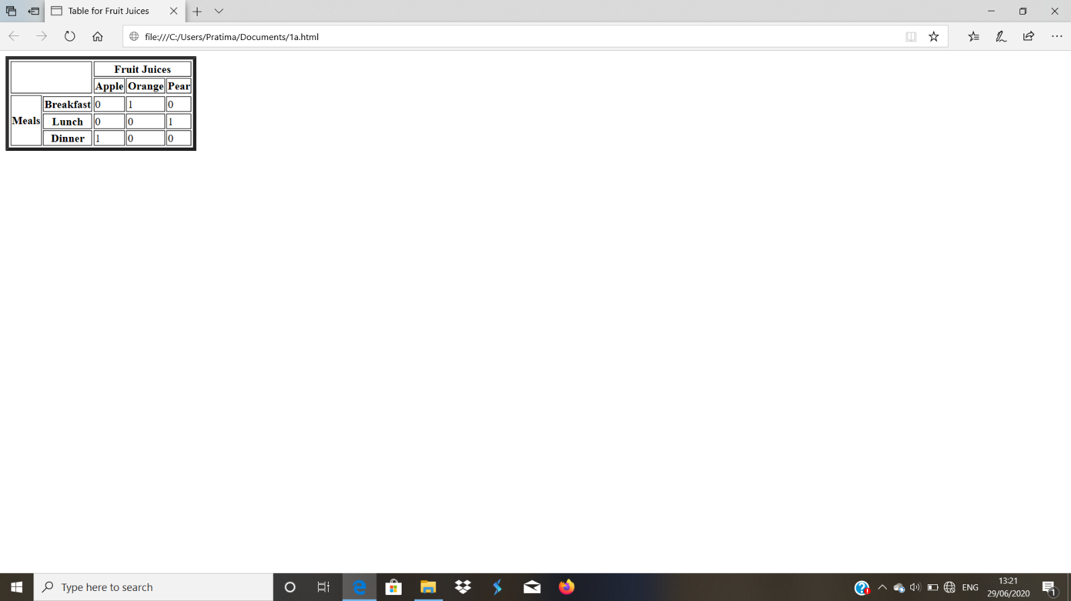

1. b.

Create an XHTML document having two vertical frames. The left frame occupies 25% of the total display width and contains an unordered list of fruit names. Each name in the left frame must be a link to a document that is displayed in the right frame when the link is selected. The documents in the right frame are short descriptions of selected fruits.

**1b.html**

<?xml version = "1.0" encoding="utf-8"?>

<!DOCTYPE html PUBLIC "-//W3C/DTD XHTML 1.0 Frameset//EN"

"http://www.w3.org/TR/xhtmll/DTD/xhtmll-frameset.dtd">

<!--frames.html

AN example to illustrate frames

-->

<html xmlns = "http://www.w3.org/1999/xhtml">

<head><title>Frames</title>

</head>

<frameset cols="25%,*">

<frame src="contents.html"/>

<frame src="fruits.html" name="descriptions"/>

</frameset>

</html>

**Contents.html**

<?xml version = "1.0" encoding="utf-8"?>

<!DOCTYPE html PUBLIC "-//W3C/DTD XHTML 1.0 Transitional//EN"

"http://www.w3.org/TR/xhtmll/DTD/xhtmll-Transitional.dtd">

<html xmlns = "http://www.w3.org/1999/xhtml">

<head><title> Table of Contents Frame</title>

</head>

<body>

<h4> Fruits </h4>

<ul>

<li><a href="apples.html" target="descriptions">apples</a></li>

<li><a href="bananas.html" target="descriptions">bananas</a></li>

<li><a href="oranges.html" target="descriptions">oranges</a></li>

</ul>

</body>

</html>

**Fruits.html**

<?xml version = "1.0" encoding="utf-8"?>

<!DOCTYPE html PUBLIC "-//W3C/DTD XHTML 1.1//EN"

"http://www.w3.org/TR/xhtmlll/DTD/xhtmlll.dtd">

<html xmlns = "http://www.w3.org/1999/xhtml">

<head><title> General Information on Fruits</title>

</head>

<body>

<p>

A fruit is the mature ovary in a flowering plant

Fruit is classified by several charecteristics,

the most important being the number of ovaries included.

If only a single ovary is included, it is called

a simple fruit.

</p>

</body>

</html>

**apples.html**

<?xml version = "1.0" encoding="utf-8"?>

<!DOCTYPE html PUBLIC "-//W3C/DTD XHTML 1.1//EN"

"http://www.w3.org/TR/xhtmlll/DTD/xhtmlll.dtd">

<html xmlns = "http://www.w3.org/1999/xhtml">

<head><title> General Information on Apple</title>

</head>

<body>

<p>

An apple a day keeps the doctor away.

An apple two day will keep doctor two away.

An apple three day will keep doctor three away.

An apple four day will keep doctor four away.

</p>

</body>

</html>

**bananas.html**

<?xml version = "1.0" encoding="utf-8"?>

<!DOCTYPE html PUBLIC "-//W3C/DTD XHTML 1.1//EN"

"http://www.w3.org/TR/xhtmlll/DTD/xhtmlll.dtd">

<html xmlns = "http://www.w3.org/1999/xhtml">

<head><title> General Information on bananas</title>

</head>

<body>

<p>

An bananas a day keeps the doctor away.

An bananas two day will keep doctor two away.

An bananas three day will keep doctor three away.

An bananas four day will keep doctor four away.

</p>

</body>

</html>

**oranges.html**

<?xml version = "1.0" encoding="utf-8"?>

<!DOCTYPE html PUBLIC "-//W3C/DTD XHTML 1.1//EN"

"http://www.w3.org/TR/xhtmlll/DTD/xhtmlll.dtd">

<html xmlns = "http://www.w3.org/1999/xhtml">

<head><title> General Information on Orange</title>

</head>

<body>

<p>

An orange a day keeps the doctor away.

An orange two day will keep doctor two away.

An orange three day will keep doctor three away.

An orange four day will keep doctor four away.

</p>

</body></html>

**Output**

**Before selecting the link:**

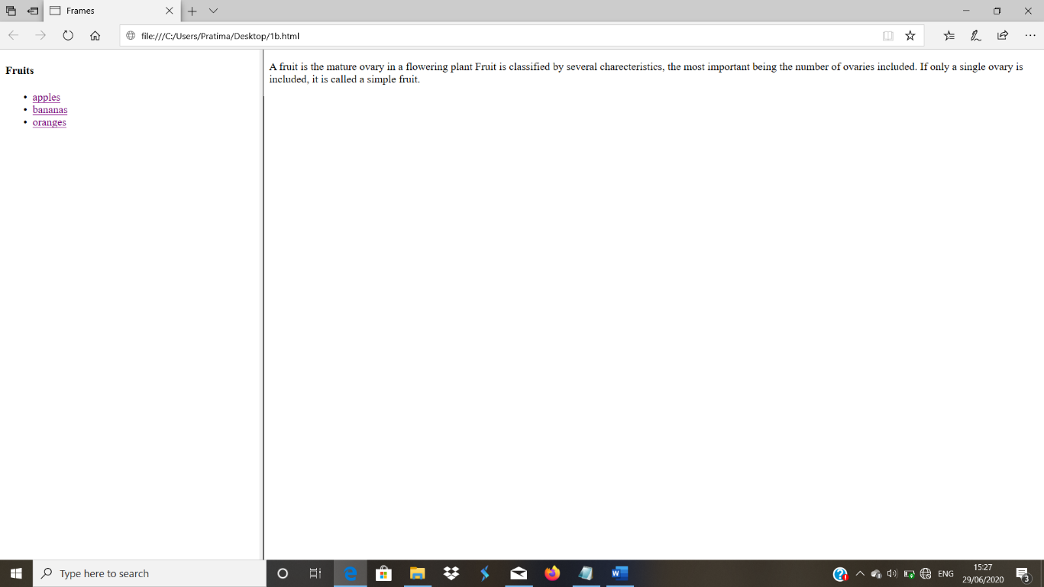

**After selecting the link:**

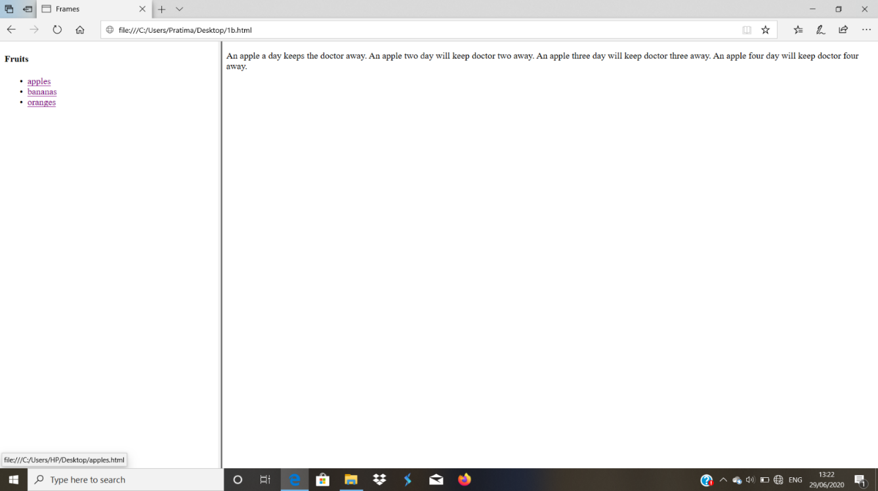

**2. a.**

Design an XHTML web page using CSS, which has two paragraphs as follows:

(i) First para – Arial font, 24 pt. size, italic, bold, text color blue, background color yellow, underlined, aligned right.

(ii) Second para – Courier font, 40 pt. size, Small capital letters, text color red, background color white, overlined, aligned center.

**2a.html**

<?xml version = "1.0" encoding = "utf-8"?>

<!DOCTYPE html PUBLIC "-//w3C//DTD XHTML 1.1//EN"

"http://www.w3.org/TR/xhtmlll/DTD/xhtmlll.dtd">

<html xmlns="http://www.w3.org/1999/xhtml">

<head>

<style type = "text/css">

p.first {font-size: 24pt;

font-style: italic;

font-weight: bold;

font-family: 'Ariel';

text-decoration: underline;

text-align: right;

background-color: yellow; }

p.second {font-size: 40pt; color: red;

font-style: italic;

font-weight: bold

font-family: 'Courier';

font-variant: small-caps;

text-decoration: overline;

text-align: center;

background-color: white; }

</style>

</head>

<body>

<p class = "first">This is the first line of the paragraph<br/>

This is the Second line of the paragraph<br/>

This is the third line of the paragraph<br/>

</p>

<p class = "second">This is the first line of the paragraph<br/>

This is the Second line of the paragraph<br/>

This is the third line of the paragraph<br/>

</p>

</body>

</html>

**Output**

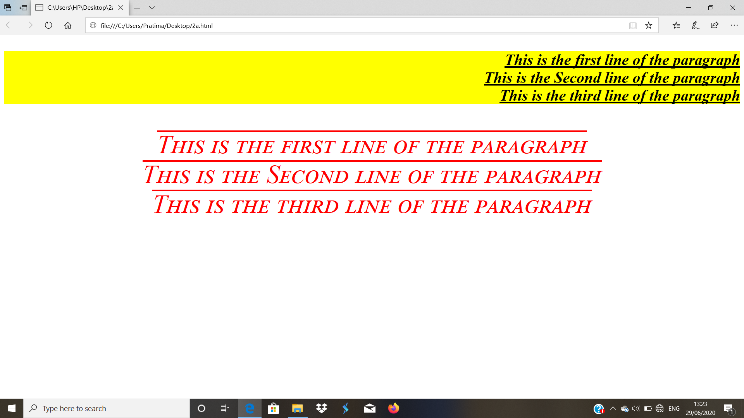

**2. b.**

Develop an XHTML web page to include a background image on some text and then illustrate the properties

‘background-repeat’ and ‘background-position’ with different values for each.

**2b.html**

<?xml version = "1.0" encoding = "utf-8"?>

<!DOCTYPE html PUBLIC "-//w3C//DTD XHTML 1.1//EN"

"http://www.w3.org/TR/xhtmlll/DTD/xhtmlll.dtd">

<html xmlns="http://www.w3.org/1999/xhtml">

<head>

<style type = "text/css">

p.first {font-size: 24pt;

font-style: italic;

font-weight: bold;

font-family: 'Ariel';

text-decoration: underline;

text-align: right;

background-color: yellow; }

p.second {font-size: 40pt;

font-style: italic;

font-weight: bold;

font-family: 'courier';

font-variant: small-caps;

text-decoration: overline;

text-align: center;

background-color: white; }

body{background-image:url("20200603_152037.jpg");

background-repeat:no-repeat;

background-position:right;}

.spanred{color:blue;}

</style>

</head>

<body>

<div class="spanred">

<p class = "first">This is the first line of the paragraph

<span class="spanred">This is the Second line of the paragraph </span>This is the third line of the paragraph

</p>

<p class = "second">This is the first line of the paragraph

This is the Second line of the paragraph

This is the third line of the paragraph

</p>

</div>

</body>

</html>

**Output**

**With no background repeat and position to the right:**

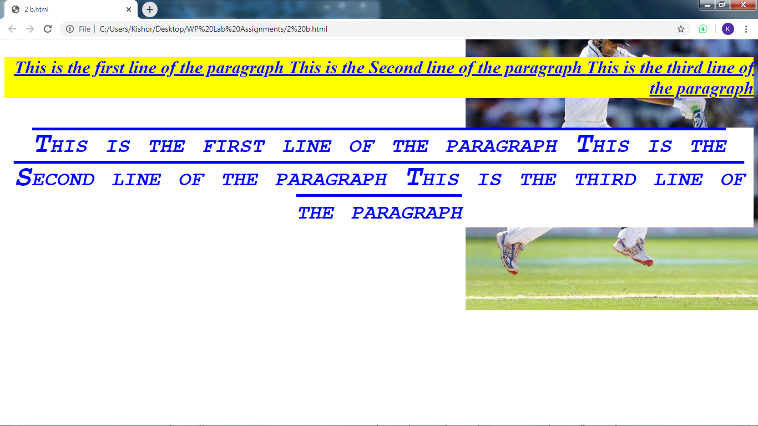

**With background repeat and position to the center:**

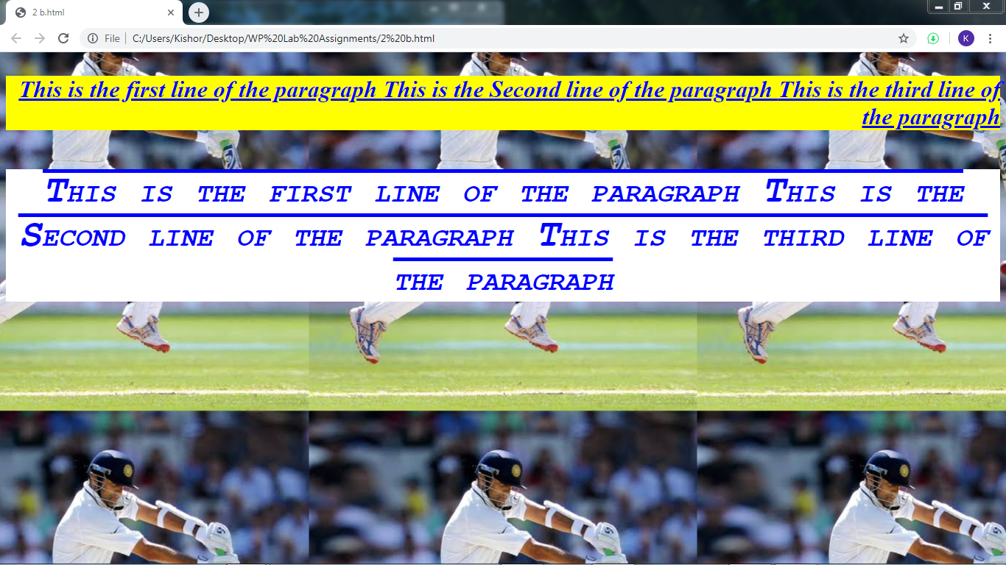

**3.**

Develop and demonstrate using JavaScript , an XHTML document that collects the USN( the valid format is : A digit from 1 to 4 followed by two uppercase characters, followed by two digits; no embedded spaces allowed) of the user. Event handler must be included for the form element that collects this information to validate the input. messages in the alert windows must be produced when errors are detected

**3.html**

<?xml version = "1.0" encoding = "utf-8"?>

<!DOCTYPE html PUBLIC "-//w3C//DTD XHTML 1.1//EN"

"http://www.w3.org/TR/xhtmlll/DTD/xhtmlll.dtd">

<html xmlns="http://www.w3.org/1999/xhtml">

<head><title> Validating USN

</title>

<script type = "text/javascript" src = "USNH.js">

</script>

</head>

<body><h4>USN</h4>

<form id = "myform1" action = "">

<p>

<label><input type = "text" id = "usn"/>

usn((D(1-4)XX(2 uppercase letters)DD(2 Digits)XX(2 uppercase letters)DDD(3 digits))</label><br/><br/>

<input type = "reset" id="reset"/>

<input type="submit" id="submit"/></p>

</form>

<script type="text/javascript" src = "USNR.js">

</script>

</body>

</html>

**USNR.js**

var usn=document.getElementById("usn");

usn.addEventListener("change",chkUsn,false);

**USNH.js**

function chkUsn(event)

{

var myUsn=event.currentTarget;

var pos=myUsn.value.search(/^[1-4]{1}[A-Z]{2}\d{2}[A-Z]{2}\d{3}/);

if(pos!=0)

{

alert(" The usn you entered("+myUsn.value+

") is not in the correct form. \n"+

"The correct form is : "+

"(D(1-4)XX(2 uppercaseletters)DD(2 Digits)XX(2 uppercaseletters)DDD(3 digits) \n"+

"please go back and fix your usn ");

myUsn.focus();

myUsn.select();

return false;

}

else

return true;

}

**Output**

**USN when entered correct**

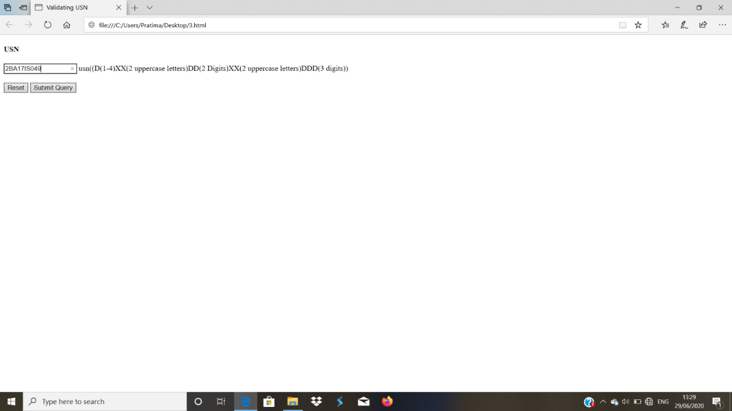

**USN when entered wrong**

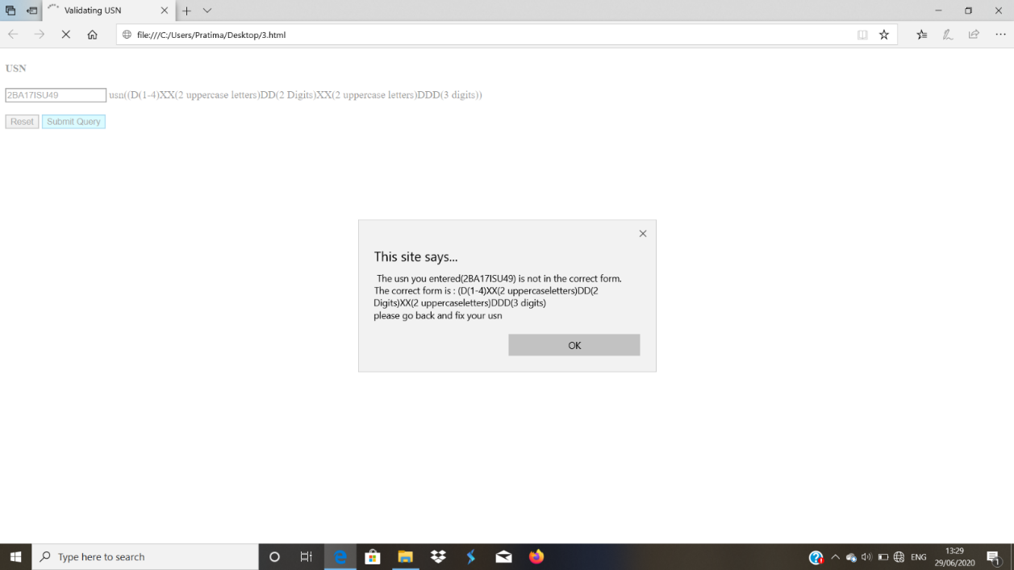

**4.**Develop XHTML documents with JavaScript scripts to handle events as follows:

**(i)** ‘blur’ event to transform the input text to upper case.

**4a.html**

<?xml version = "1.0" encoding = "utf-8"?>

<!DOCTYPE html PUBLIC "-//w3C//DTD XHTML 1.1//EN"

"http://www.w3.org/TR/xhtmlll/DTD/xhtmlll.dtd">

<html xmlns="http://www.w3.org/1999/xhtml">

<head><title> Handling blur event

</title>

<script type = "text/javascript" src = "BlurH.js">

</script>

</head>

<body>

<form id = "myform1" action = "">

<p>

<label><input type = "text" id = "Name"/>

Name</label><br/><br/>

<input type = "reset" id="reset"/>

<input type="submit" id="submit"/></p>

</form>

<script type="text/javascript" src = "BlurR.js">

</script>

</body>

</html>

**BlurR.js**

var aname=document.getElementById("Name");

aname.addEventListener("blur",toUppercase,false);

**BlurH.js**

function toUppercase(event)

{

var bname=event.currentTarget;

var ssrt=bname.value;

bname.value=ssrt.toUpperCase();

return false;

}

**Output**

**Before blur:**

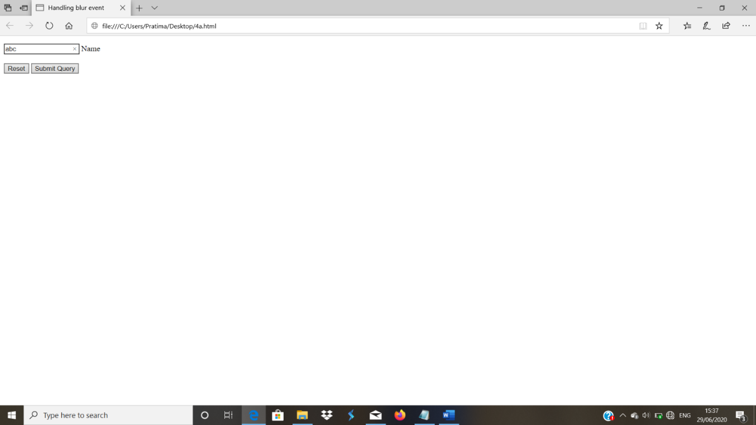

**After Blur:**

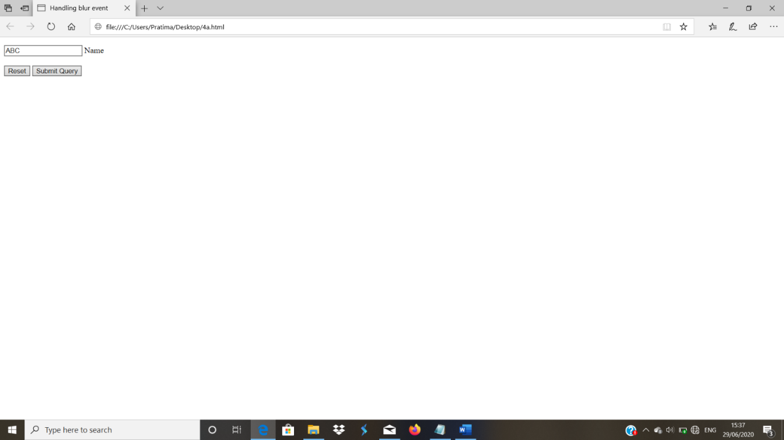

**(ii)** ‘focus’ event to change the background color of a text box.

**4b.html**

<?xml version = "1.0" encoding = "utf-8"?>

<!DOCTYPE html PUBLIC "-//w3C//DTD XHTML 1.1//EN"

"http://www.w3.org/TR/xhtmlll/DTD/xhtmlll.dtd">

<html xmlns="http://www.w3.org/1999/xhtml">

<head><title> Handling Focus event

</title>

<script type = "text/javascript" src = "FocusH.js">

</script>

</head>

<body>

<form id = "myform1" action = "">

<p>

<label><input type = "text" id = "Name"/>

Name</label><br/><br/>

<input type = "reset" id="reset"/>

<input type="submit" id="submit"/></p>

</form>

<script type="text/javascript" src = "FocusR.js">

</script>

</body>

</html>

**FocusR.js**

var aname=document.getElementById("Name");

aname.addEventListener("focus",bgChange,false);

aname.addEventListener("blur",bgReplace,false);

**FocusH.js**

function bgChange(event)

{

var bname=event.currentTarget;

document.body.style.backgroundColor = "red";

return false;

}

function bgReplace(event)

{

var bname=event.currentTarget;

document.body.style.backgroundColor = "white";

return false;

}

**Output**

**Before focus:**

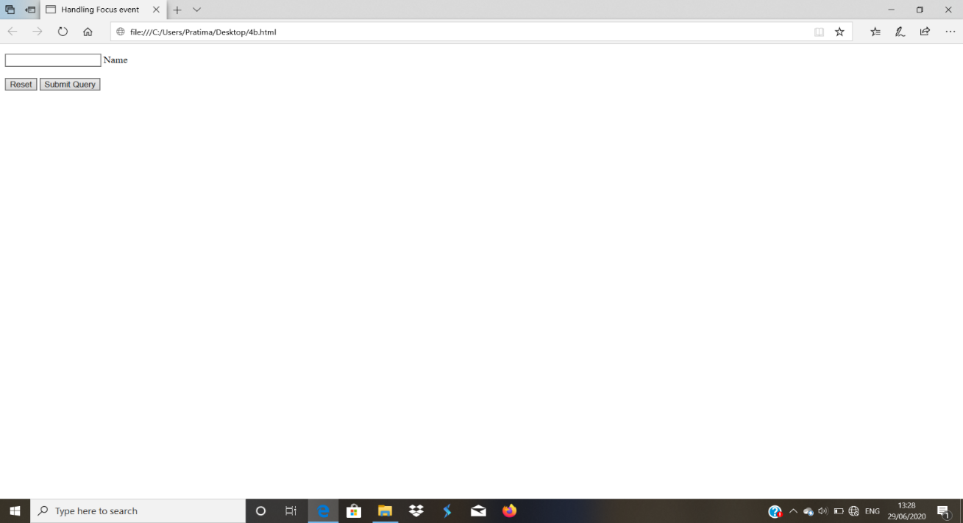

**After focus:**

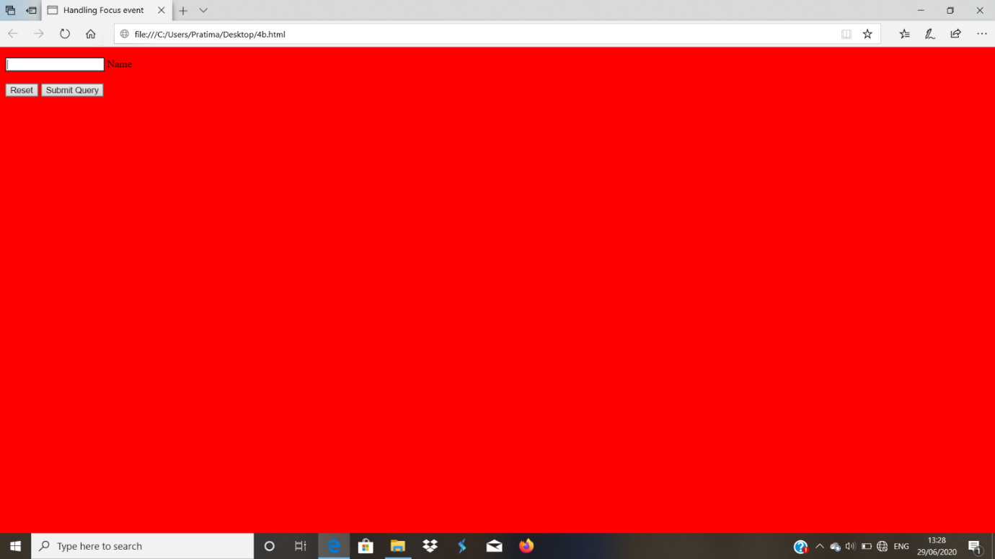

**(iii)** ‘Change’ event to display the preferred browser in an alert box, when the user selects the browser from drop-down menu.

**4c.html**

<?xml version = "1.0" encoding = "utf-8"?>

<!DOCTYPE html PUBLIC "-//w3C//DTD XHTML 1.1//EN"

"http://www.w3.org/TR/xhtmlll/DTD/xhtmlll.dtd">

<html xmlns="http://www.w3.org/1999/xhtml">

<head><title>Change Event</title>

<script type = "text/javascript" src = "Change.js"> </script>

</head>

<body><h4>Web Browser</h4>

<form id = "myform" action = "">

<select id="Browser" onChange="webbrowser()" >

<label><option value = "1" />

Google Chrome</label>

<label><option value = "2"/>

Mozilla</label>

<label><option value = "3" />

Internet Explorer</label>

</select>

</form>

</body>

</html>

**Change.js**

function webbrowser()

{

var dom=document.getElementById("Browser");

var op=dom.value;

switch (op)

{

case "1":

alert("Your preferred browser is Google Chrome");

break;

case "2":

alert("Your preferred browser is Mozilla Firefox");

break;

case "3":

alert("Your preferred browser is Internet Explorer");

break;

default:

alert("You have selected wrong option");

break;

}

}

**Output**

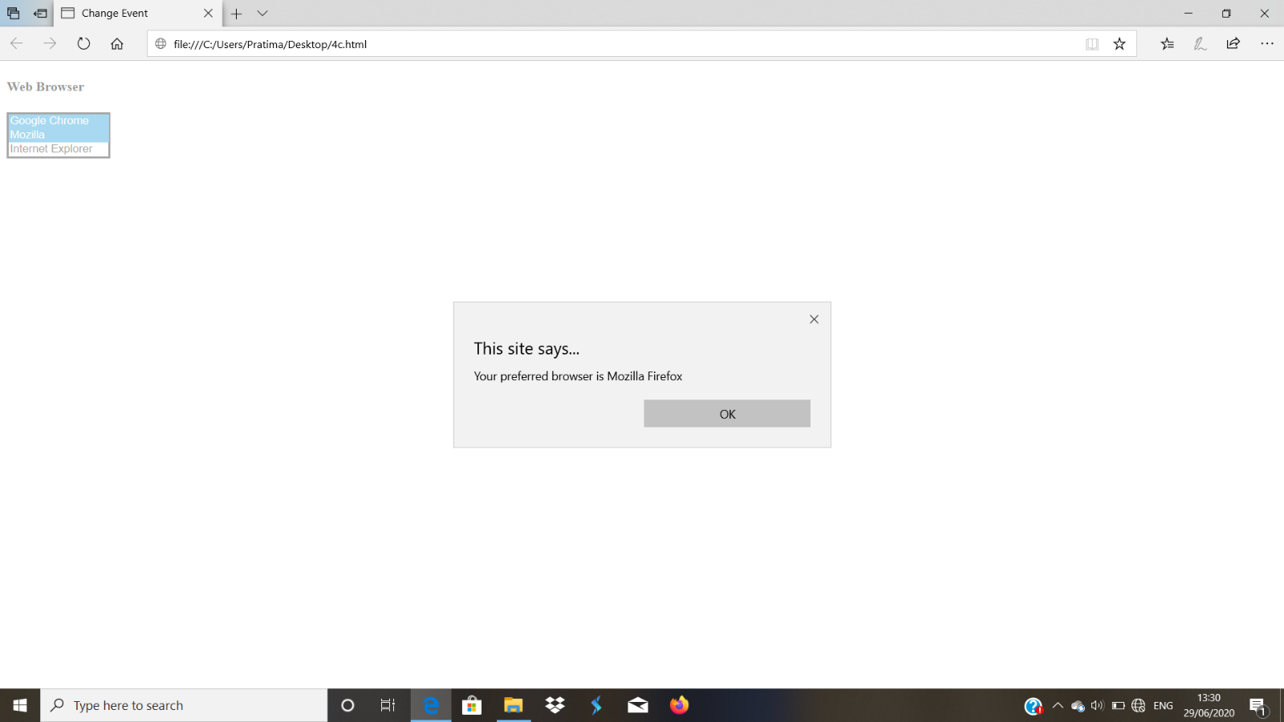

Internet Explorer

**(iv)** ‘click’ event to copy the contents of one text box into another.

**4d.html**

<?xml version = "1.0" encoding = "utf-8"?>

<!DOCTYPE html PUBLIC "-//w3C//DTD XHTML 1.1//EN"

"http://www.w3.org/TR/xhtmlll/DTD/xhtmlll.dtd">

<html xmlns="http://www.w3.org/1999/xhtml">

<head><title>Click Event

</title>

<script type = "text/javascript" src = "copytext.js">

</script>

</head>

<body>

<form id = "myform" action = "">

<label>T1<input type = "text" id = "t1"/>

</label><br/>

<label>T2<input type = "text" id = "t2" />

</label><br/><br/>

<input type="button" value="CLick to Copy" onclick="copytxtbox()" />

</form>

</body>

</html>

**copytext.js**

function copytxtbox()

{

document.getElementById("t2").value=document.getElementById("t1").value;

return false;}

**Output:**

**Before click:**

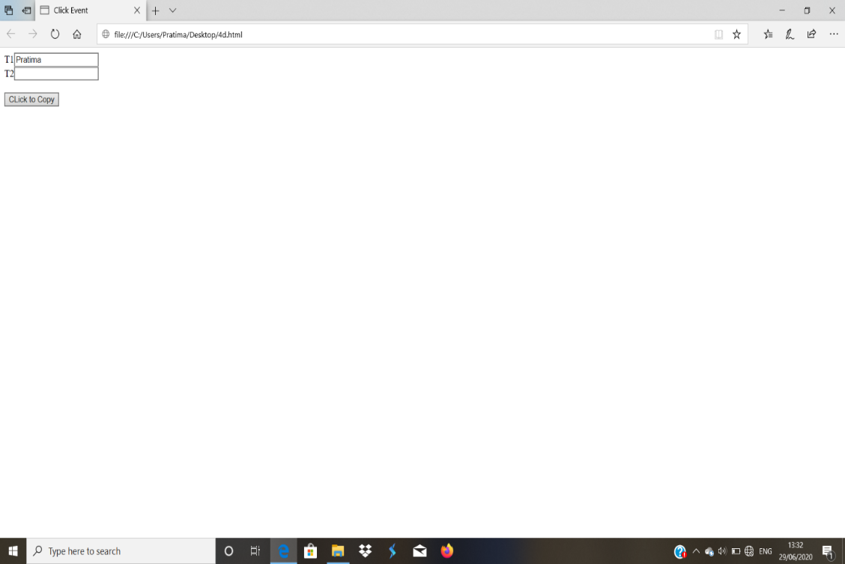

**After click:**

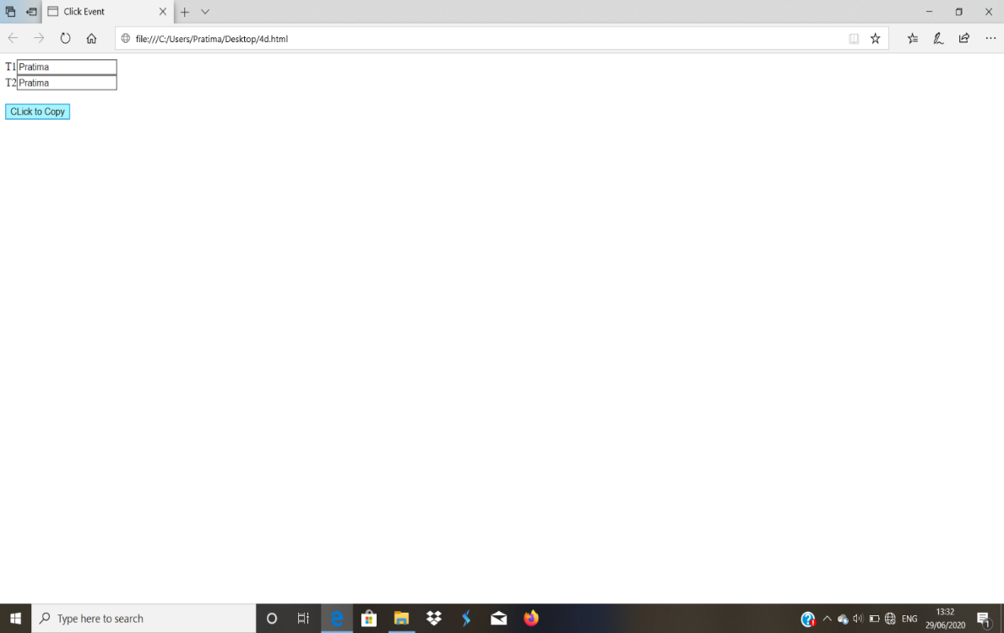

**5.**

Create and demonstrate an XHTML document using JavaScript script for event handling as follows:

XHTML document should contain a set of radio buttons showing names of web programming tools. On clicking a particular button, event handler should be called to display a brief description about the selected tool , using an alert box

**5th.html**

<?xml version = "1.0" encoding = "utf-8"?>

<!DOCTYPE html PUBLIC "-//w3C//DTD XHTML 1.1//EN"

"http://www.w3.org/TR/xhtmlll/DTD/xhtmlll.dtd">

<html xmlns="http://www.w3.org/1999/xhtml">

<head><title>radio_click</title>

<script type = "text/javascript" src = "radio_click.js"></script>

</head>

<body><h4>Web tools</h4>

<form id = "myform" action = "">

<label><input type = "radio" name = "webtools"

value = "1"

onclick = "webtoolapp(1)" />

HTML</label>

<label><input type = "radio" name = "webtools"

value = "2"

onclick = "webtoolapp(2)" />

XML</label>

<label><input type = "radio" name = "webtools"

value = "3"

onclick = "webtoolapp(3)" />

CSS</label>

</form>

</body>

</html>

**radio_click.js**

function webtoolapp(op)

{

switch (op)

{

case 1:

alert("You have chosen HyperTextMarkupLanguage");

break;

case 2:

alert("You have chosen xml");

break;

case 3:

alert("You have chosen Cascading Style Sheets");

break;

}

}

**Output:**

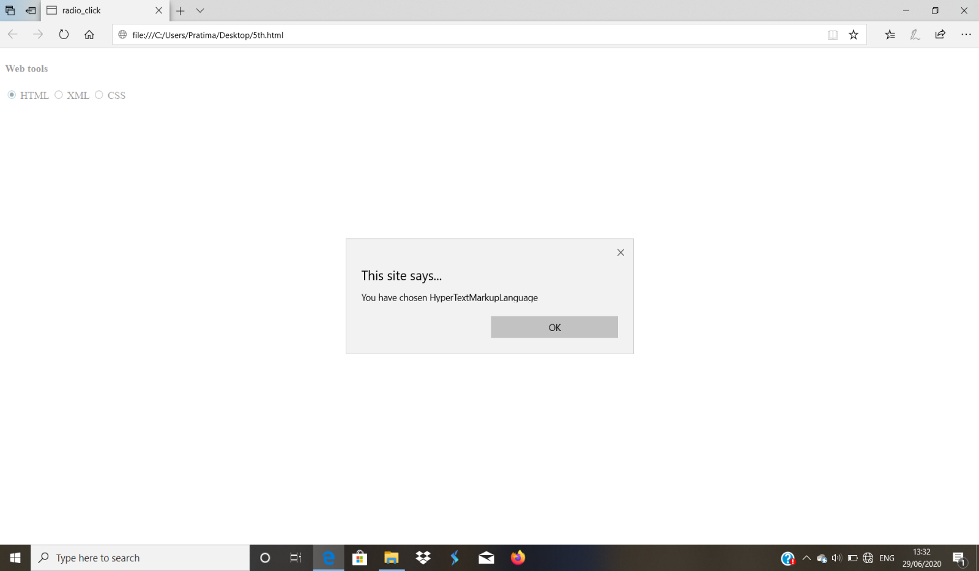

**6.**

Develop and demonstrate an XHTML document as follows:

The XHTML document must contain four paragraphs , stacked on the top of each other with only enough of each showing so that the mouse cursor can always be placed over some part of them. When cursor is placed over the exposed part of any paragraph, it should rise to the top to become completely visible.

**6th.html**

<?xml version = "1.0" encoding = "utf-8"?>

<!DOCTYPE html PUBLIC "-//w3C//DTD XHTML 1.1//EN"

"http://www.w3.org/TR/xhtmlll/DTD/xhtmlll.dtd">

<html xmlns="http://www.w3.org/1999/xhtml">

<head>

<title>Paragraph Stack Ordering</title>

<script type=text/javascript src = "stacking.js">

</script>

<style type="text/css">

#layer1

{

border:solid thick black;

background-color:brown;

padding:10px;

width:300px;

height:200px;

position:absolute;

top:100px;

left:200px;

z-index:0;

}

#layer2

{

border:solid thick black;

background-color:gray;

padding:10px;

width:300px;

height:200px;

position:absolute;

top:120px;

left:220px;

z-index:0;

}

#layer3

{

border:solid thick black;

background-color:blue;

padding:10px;

width:300px;

height:200px;

position:absolute;

top:140px;

left:240px;

z-index:0;

}

#layer4

{

border:solid thick black;

background-color:white;

padding:10px;

width:300px;

height:200px;

position:absolute;

top:160px;

left:260px;

z-index:0;

}

</style>

</head>

<body>

<p id=layer1 onMouseOver=mover('layer1');>This is the 1st layer</p>

<p id=layer2 onMouseOver=mover('layer2');>This is the 2nd layer</p>

<p id=layer3 onMouseOver=mover('layer3');>This is the 3rd layer</p>

<p id=layer4 onMouseOver=mover('layer4');>This is the 4th layer</p>

</body>

</html>

**stacking.js**

var topLayer="layer4";

function mover(toTop)

{

document.getElementById(topLayer).style.zIndex="0";

document.getElementById(toTop).style.zIndex="1";

topLayer=toTop;

}

**Output:**

**Before mouseover:**

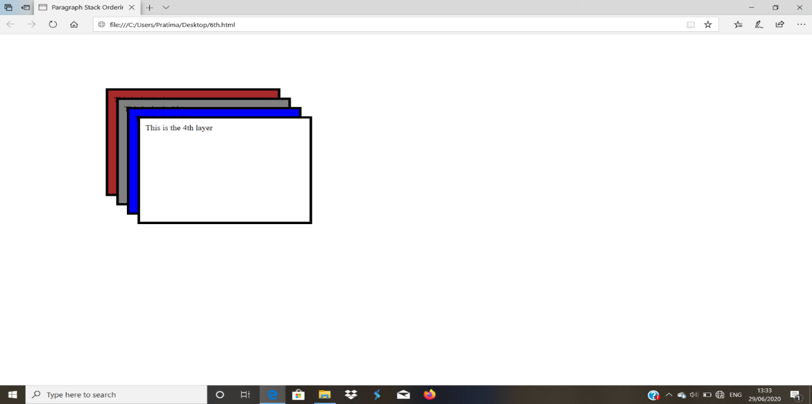

**After mouseover:**

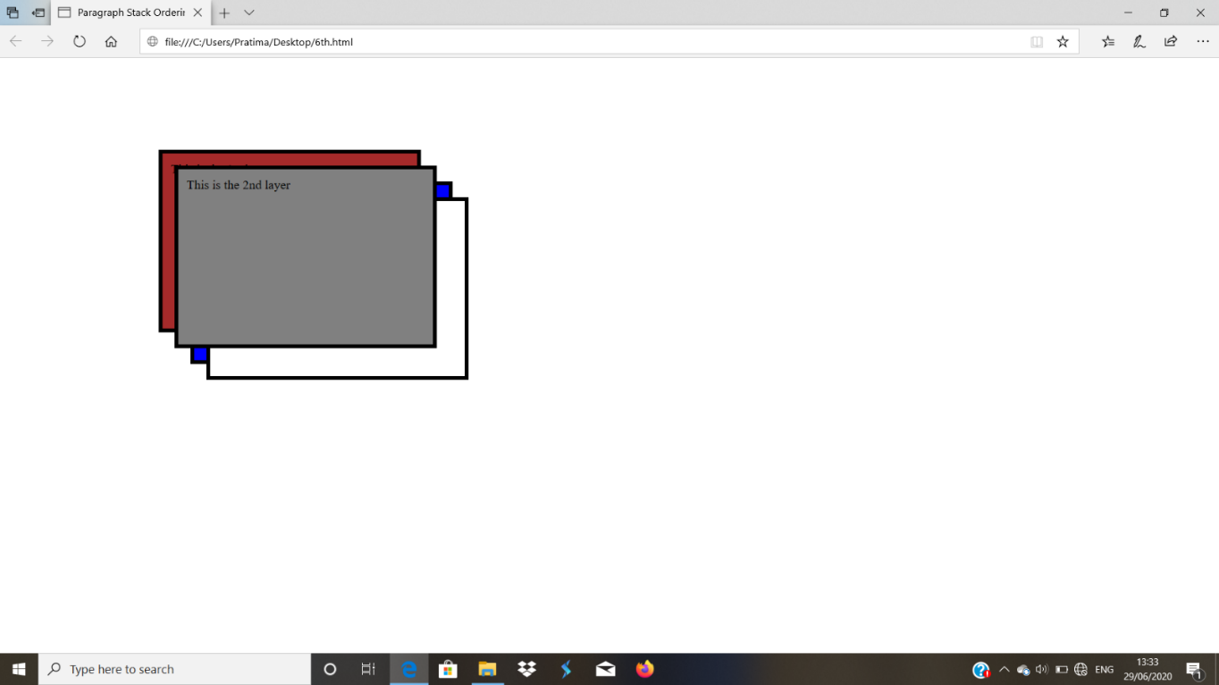

**7. a.**

Create an XML documentfor a catalog of cars, where each car has the child elements make, model, year, color, engine, number of doors, transmission- type and accessories. The engine element has the child elements number-of-cylinders and fuel system carbureted or fuel injected. Display the document using CSS.

**7a.xml**

<?xml version="1.0" encoding="utf-8"?>

<?xml-stylesheet type="text/css" href="catalog.css"?>

<catalog>

<car>

<model>001</model><e/>

<year>2009</year><e/>

<color>black</color><e/>

<door>4</door>

<engine>

<fuelsystem>petrol</fuelsystem><e/>

<noofcylinders>3</noofcylinders><e/>

</engine>

<transmissiontype>yes</transmissiontype><e/>

<accessories>

<radio>yes</radio><e/>

<airconditioner>yes</airconditioner><e/>

<powerwindow>yes</powerwindow><e/>

<powerbreak>yes</powerbreak><e/>

</accessories>

</car>

<e/>

<e/>

<car>

<model>002</model><e/>

<year>2014</year><e/>

<color>blue</color><e/>

<door>4</door>

<engine>

<fuelsystem>diesel</fuelsystem><e/>

<noofcylinders>5</noofcylinders><e/>

</engine>

<transmissiontype></transmissiontype>

<accessories>

<radio>yes</radio><e/>

<airconditioner>no</airconditioner><e/>

<powerwindow>no</powerwindow><e/>

<powerbreak>yes</powerbreak><e/>

</accessories>

</car>

<e/>

<e/>

<car>

<model>003</model><e/>

<year>2020</year><e/>

<color>red</color><e/>

<door>4</door>

<engine>

<fuelsystem>petrol</fuelsystem><e/>

<noofcylinders>6</noofcylinders><e/>

</engine>

<transmissiontype></transmissiontype>

<accessories>

<radio>yes</radio><e/>

<airconditioner>yes</airconditioner><e/>

<powerwindow>yes</powerwindow><e/>

<powerbreak>yes</powerbreak><e/>

</accessories>

</car>

</catalog>

**Catalog.css**

car{color:blue;font-size:20px}

model{color:red;font-size:20px}

year{color:yellow;font-size:20px}

color{color:orange;font-size:20px}

door{color:green;font-size:20px}

engine{color:pink;font-size:20px}

e{display:block}

catalog{background-color: black;}

**Output:**

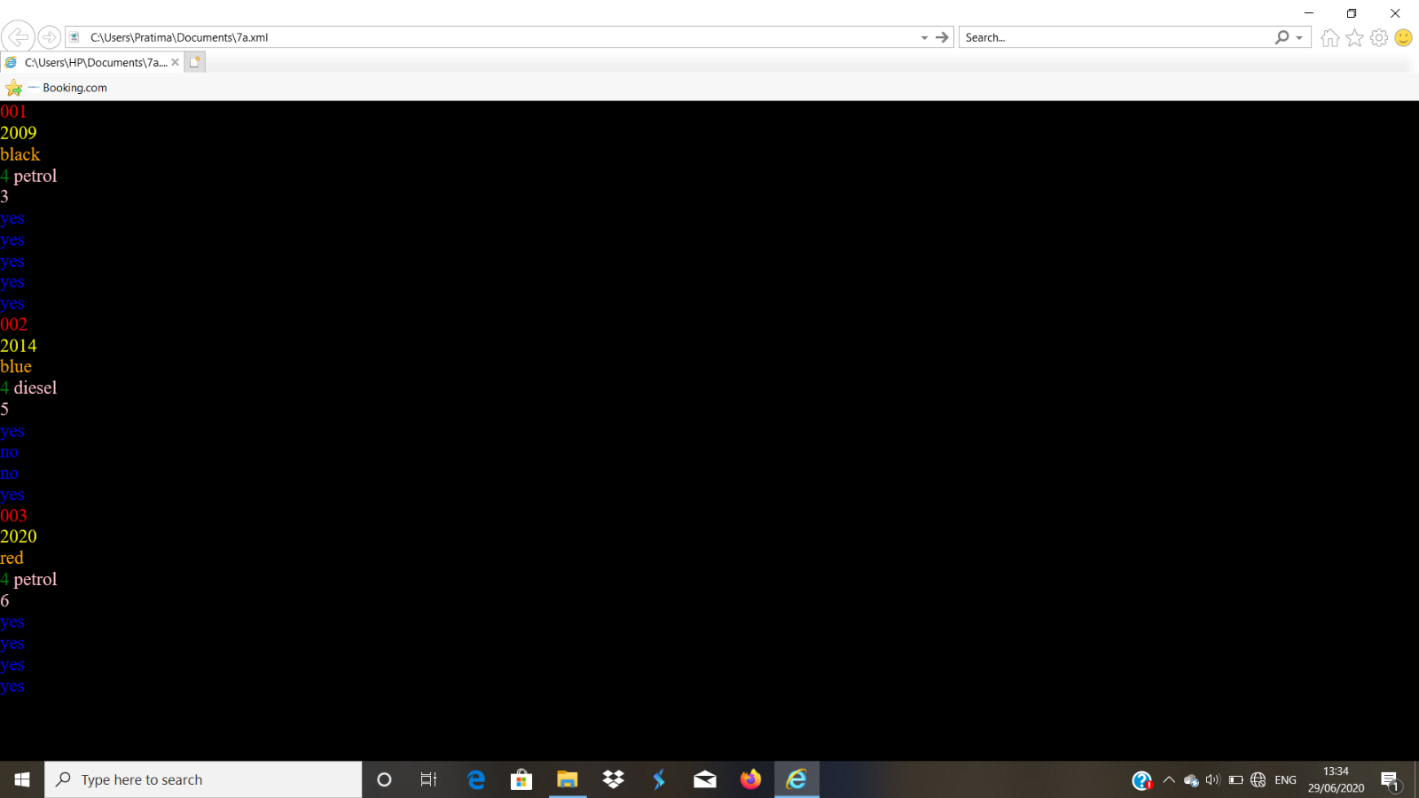

**7. b.**

Display the same using XSLT

**7b.xml**

<?xml version="1.0" encoding="utf-8"?>

<?xml-stylesheet type="text/xsl" href="a.xsl"?>

<catalog>

<car>

<model>001</model><e/>

<year>2009</year><e/>

<color>black</color><e/>

<door>4</door>

<engine>

<fuelsystem>petrol</fuelsystem><e/>

<noofcylinders>3</noofcylinders><e/>

</engine>

<transmissiontype>yes</transmissiontype><e/>

<accessories>

<radio>yes</radio><e/>

<airconditioner>yes</airconditioner><e/>

<powerwindow>yes</powerwindow><e/>

<powerbreak>yes</powerbreak><e/>

</accessories>

</car>

<e/>

<e/>

<car>

<model>002</model><e/>

<year>2014</year><e/>

<color>blue</color><e/>

<door>4</door>

<engine>

<fuelsystem>diesel</fuelsystem><e/>

<noofcylinders>5</noofcylinders><e/>

</engine>

<transmissiontype></transmissiontype>

<accessories>

<radio>yes</radio><e/>

<airconditioner>no</airconditioner><e/>

<powerwindow>no</powerwindow><e/>

<powerbreak>yes</powerbreak><e/>

</accessories>

</car>

<e/>

<e/>

<car>

<model>003</model><e/>

<year>2020</year><e/>

<color>red</color><e/>

<door>4</door>

<engine>

<fuelsystem>petrol</fuelsystem><e/>

<noofcylinders>6</noofcylinders><e/>

</engine>

<transmissiontype></transmissiontype>

<accessories>

<radio>yes</radio><e/>

<airconditioner>yes</airconditioner><e/>

<powerwindow>yes</powerwindow><e/>

<powerbreak>yes</powerbreak><e/>

</accessories>

</car>

</catalog>

**a.xsl**

<?xml version="1.0" encoding="utf-8"?>

<xsl:stylesheet version='1.0' xmlns:xsl="http://www.w3.org/1999/XSL/Transform">

<xsl:template match="/catalog">

<html>

<body>

<table border="1">

<tr>

<th>model</th>

<th>year</th>

<th>color</th>

<th>door</th>

<th>engine</th>

<th>accessories</th>

</tr>

<xsl:for-each select="car">

<tr>

<td><span style="font-size:20px"><xsl:value-of select="model"/></span></td>

<td><span style="font-size:20px"><xsl:value-of select="year"/></span></td>

<td><span style="font-size:20px"><xsl:value-of select="color"/></span></td>

<td><span style="font-size:20px"><xsl:value-of select="door"/></span></td>

<td><span style="font-size:20px"><xsl:value-of select="engine"/></span></td>

<td><span style="font-size:20px"><xsl:value-of select="accessories"/></span></td>

</tr>

</xsl:for-each>

</table>

</body></html>

</xsl:template>

</xsl:stylesheet>

**Output:**

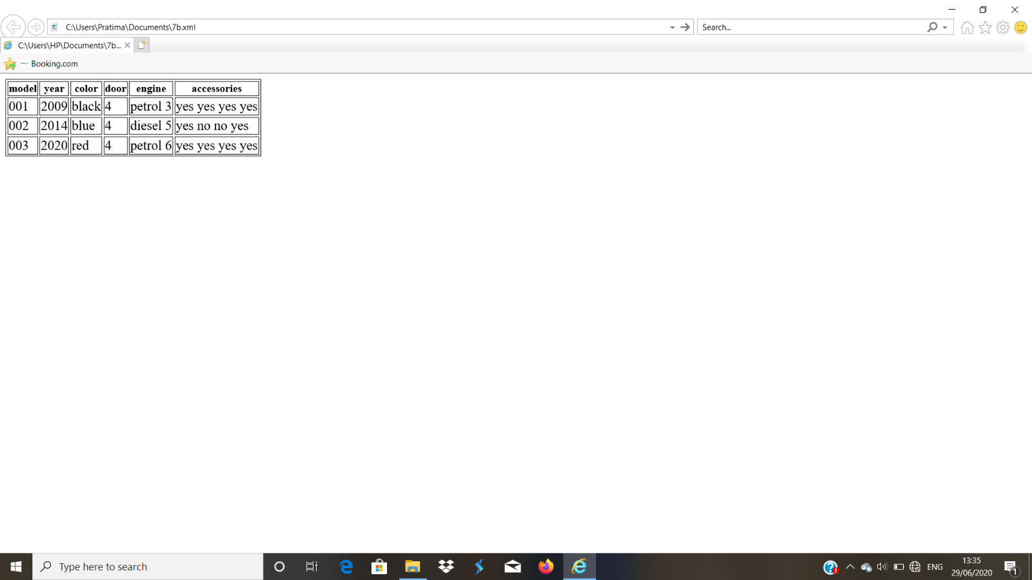

**8.**

Write XHTML code to create a table as follows and enter the quantity required.

|  |  |  |
| --- | --- | --- |
| Product Name | Price/item (Rs) | Quantity |
| A | 20 |  |
| B | 30 |  |
| C | 40 |  |

Create a set of radio buttons to accept the payment method used – Cheque, Cash, or Card. Develop PHP script to display result in a table, which should contain product name, price, quantity and total cost for each product. Below the table, display total number of ordered items the total cost and the payment used.

**8.html**

<?xml version = "1.0" encoding = "utf-8"?>

<!DOCTYPE html PUBLIC "-//w3C//DTD XHTML 1.1//EN"

"http://www.w3.org/TR/xhtmlll/DTD/xhtmlll.dtd">

<html xmlns="http://www.w3.org/1999/xhtml">

<head>

</head>

<body>

<form action = "8.php" method="post">

<table border="border">

<th colspan="4" > PRODUCT ORDER FORM </th>

<tr>

<th> Product name </th>

<th> Price/Item (Rs) </th>

<th> Quantity </th>

</tr>

<tr>

<th> A </th>

<td> 20 </td>

<td align="center"> <input type="text" name="A" size="3"/> </td>

</tr>

<tr>

<th> B </th>

<td> 30 </td>

<td align="center"> <input type="text" name="B" size="3"/> </td>

</tr>

<tr>

<th> C </th>

<td> 40 </td>

<td align="center"> <input type="text" name="C" size="3"/> </td>

</tr>

</table>

<p />

<h3> Payemnt Method </h3>

<p>

<label><input type = "radio" name = "payment"

value = "Cash"

checked="checked" />

Cash</label><br/>

<label><input type = "radio" name = "payment"

value = "Cheque"

/>

Cheque</label><br/>

<label><input type = "radio" name = "payment"

value = "Card"

/>

Card</label><br/>

<input type="submit" value="Submit Order" />

<input type="reset" value="Clear Order Form" />

</p>

</form>

</body>

</html>

**8.php**

<?xml version = "1.0" encoding = "utf-8"?>

<!DOCTYPE html PUBLIC "-//w3C//DTD XHTML 1.1//EN"

"http://www.w3.org/TR/xhtmlll/DTD/xhtmlll.dtd">

<html xmlns="http://www.w3.org/1999/xhtml">

<head>

<title> Process the form in php </title>

</head>

<body>

<?php

$a=$_POST["A"];

$b=$_POST["B"];

$c=$_POST["C"];

$payment=$_POST["payment"];

if($a=="") $a=0;

if($b=="") $b=0;

if($c=="") $c=0;

$a_cost=20*$a;

$b_cost=30*$b;

$c_cost=40*$c;

$totalprice=$a_cost+$b_cost+$c_cost;

$totalitems=$a+$b+$c;

?>

<P /><p />

<table border="border">

<caption> ORDER INFORMATION </caption>

<tr>

<th> Product name </th>

<th> Unit Price (Rs) </th>

<th> Quantity Ordered</th>

<th> Item Cost (Rs) </th>

</tr>

<tr align="center">

<th> A </th>

<td> 20 </td>

<td> <?php print ("$a"); ?> </td>

<td> <?php printf (" %4.2f ",$a_cost); ?> </td>

</tr>

<tr align="center">

<th> B </th>

<td> 30 </td>

<td> <?php print ("$b"); ?> </td>

<td> <?php printf (" %4.2f ",$b_cost); ?> </td>

</tr>

<tr align="center">

<th> C </th>

<td> 40 </td>

<td> <?php print ("$c"); ?> </td>

<td> <?php printf (" %4.2f ",$c_cost); ?> </td>

</tr>

</table>

<p />

<p />

<?php

print "You ordered $totalitems items <br />";

printf ("Your total bill is: %5.2f Rs<br />",$totalprice);

print "Your chosen method of payment is: $payment <br />";

?>

</body>

</html>

**Output:**

**Before form processing:**

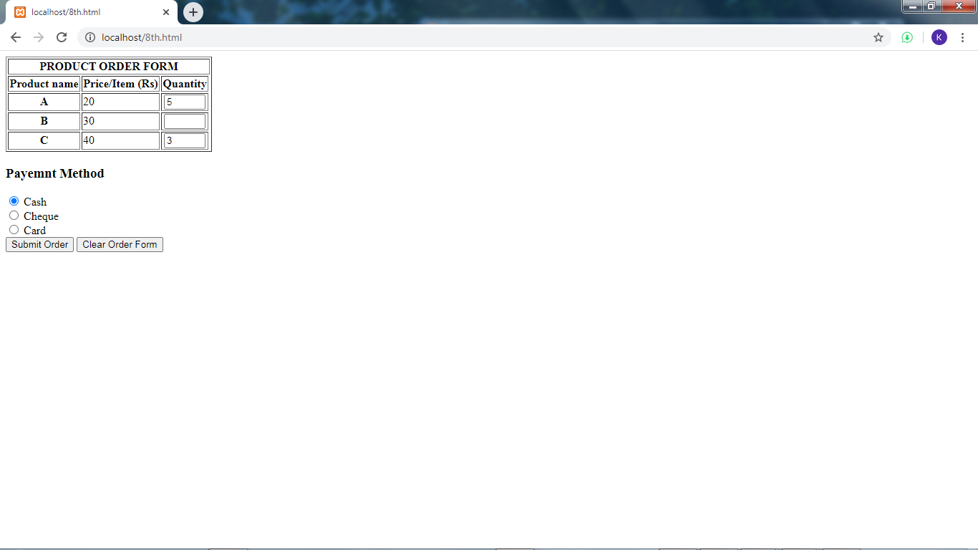

**After form processing:**

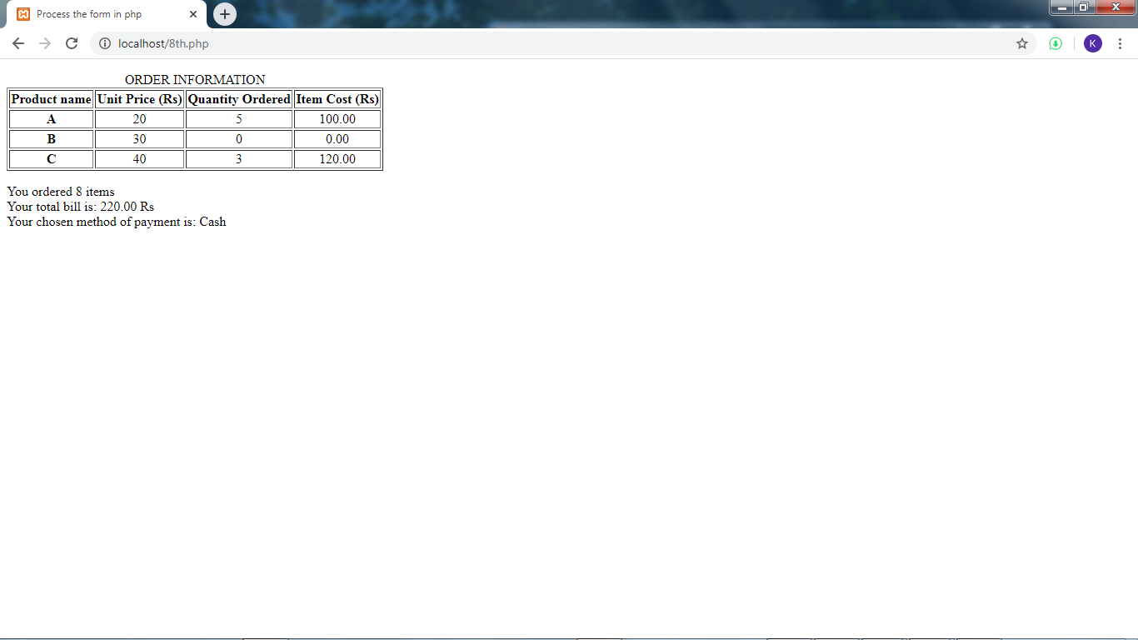

**9.**

Create an XHTML document to accept the student data which contains student name, branch and college name. Write a PHP document to insert data into the MYSQL data base and retrieve particular data based on student name from the database and display it.

**Student.html**

<html>

<body>

<form method="post" action="student.php">

<fieldset>

Student name:<input type="text" name="sname" /><br/>

Branch:<input type="text" name="branch" /><br/>

College:<input type="text" name="colg" /><br/>

Submit:<input type="Submit"/><br/>

</fieldset></form>

<form method="get" action="student1.php">

<fieldset>

Enter the Student name:<input type="text" name="sname1" /><br/>

Submit:<input type="Submit"/><br/>

</fieldset></form>

</body></html>

**student.php**

<?php

$sn=$_POST["sname"];

$br=$_POST["branch"];

$col=$_POST["colg"];

$con=mysqli_connect('localhost','root');

mysqli_select_db($con,"student");

$enter="INSERT into student(studname,branch,college) values('$sn','$br','$col')";

if(mysqli_query($con,$enter))

print("data Successfully entered");

else

print("data not entered");

?>

**student1.php**

<?php

$stn=$_GET["sname1"];

$con=mysqli_connect('localhost','root');

mysqli_select_db($con,"student");

$query="Select * from student where studname='$stn'";

if(mysqli_num_rows(mysqli_query($con,$query))>0)

print("Results Found");

else

print("results not found");

?>

**Output:**

**Database before insertion**

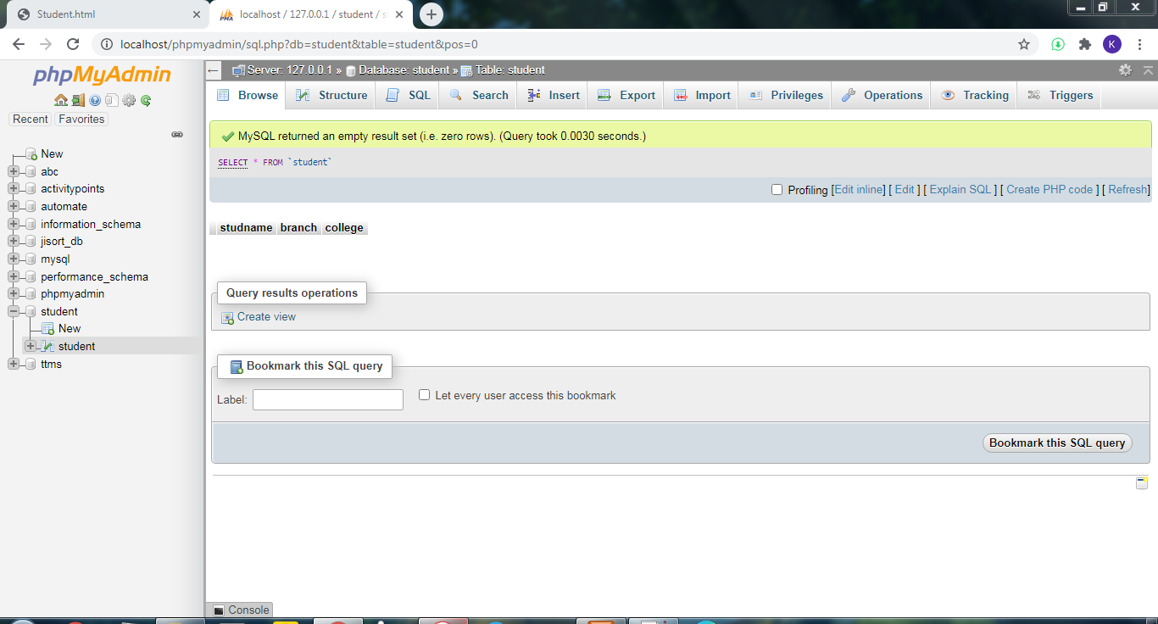

**Page Before Insertion**

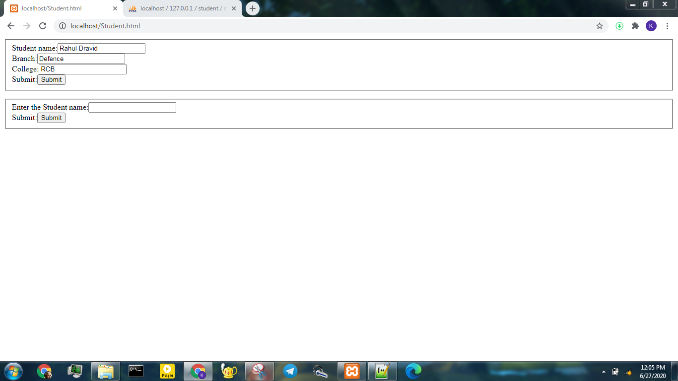

**Page after Insertion**

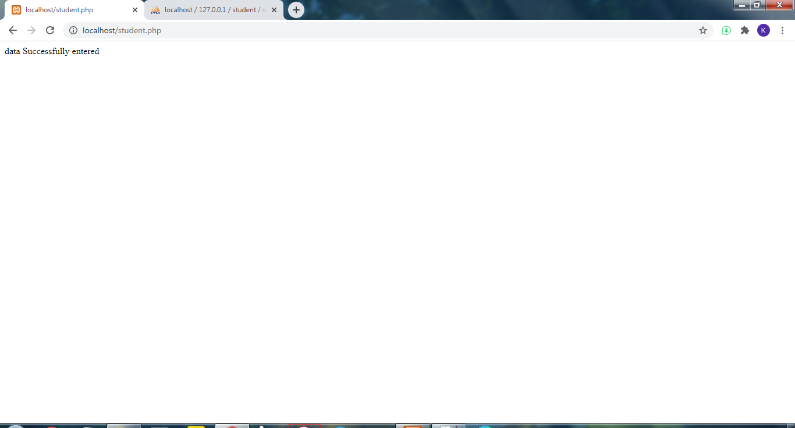

**Database after Insertion**

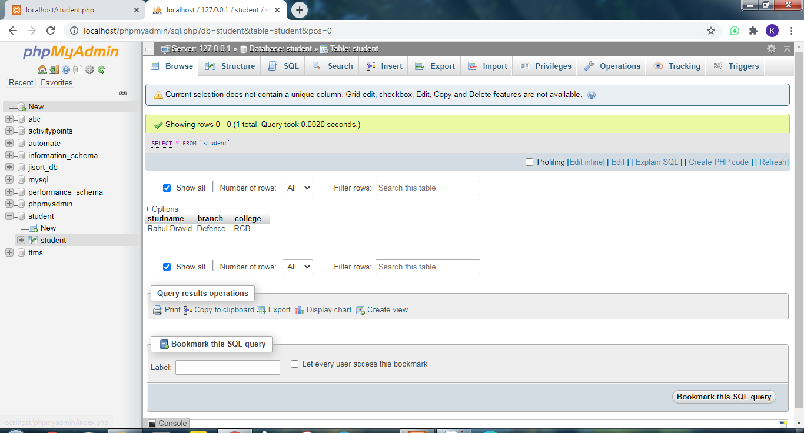

**Page before Successful Search**

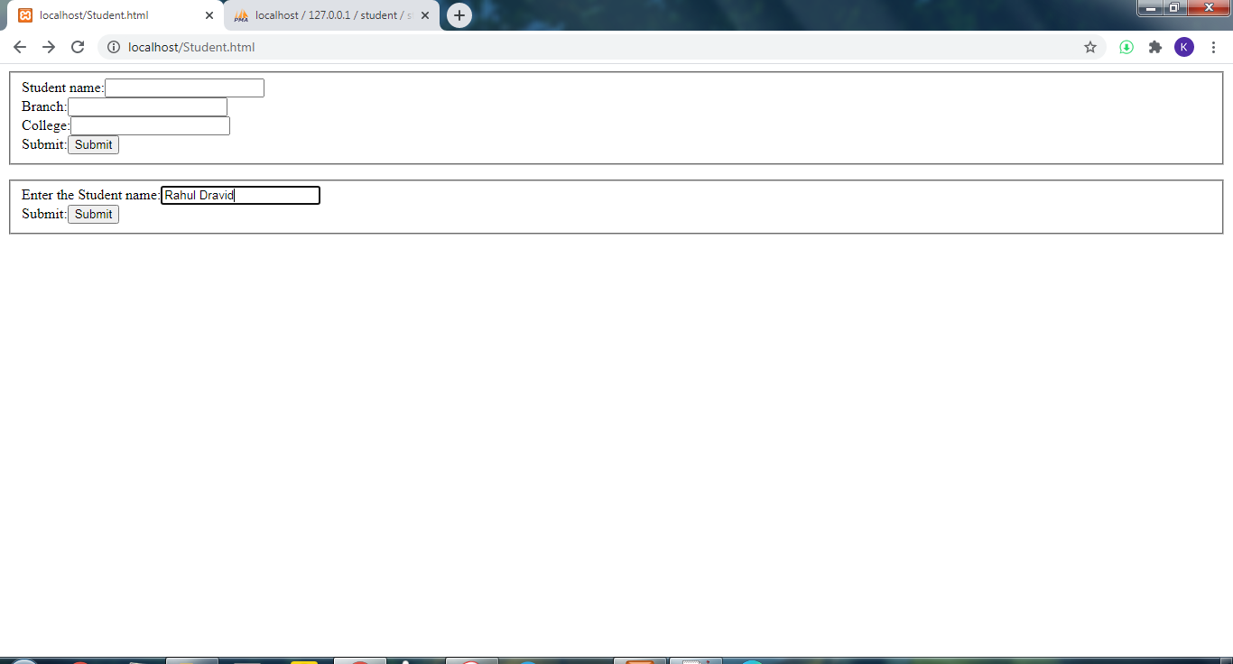

**Page after Successful Search**

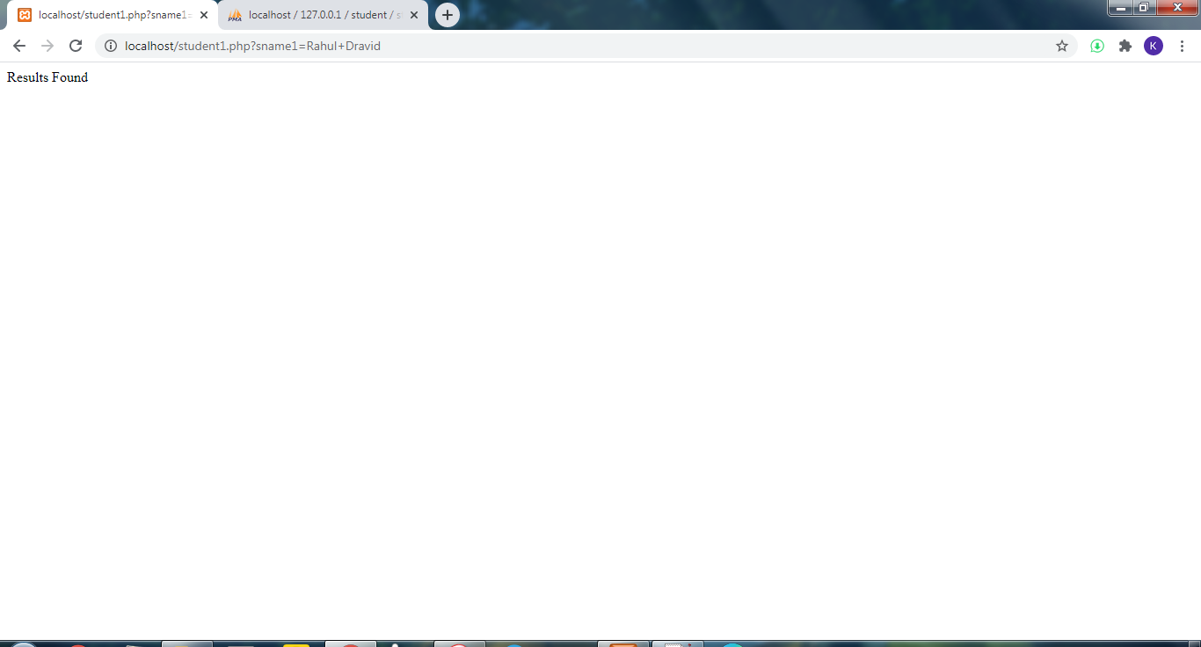

**Page before Unsuccessful Search**

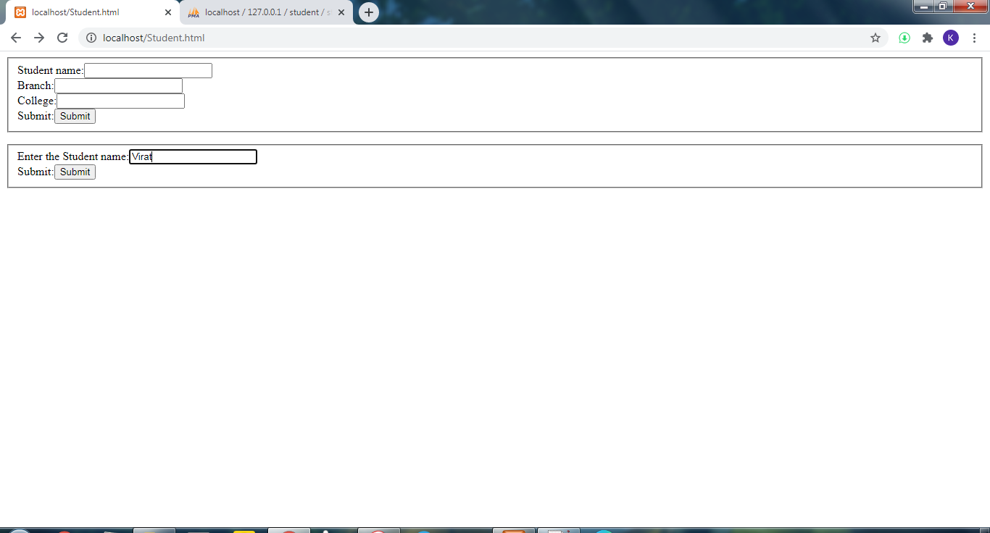

**Page after Unsuccessful Search**

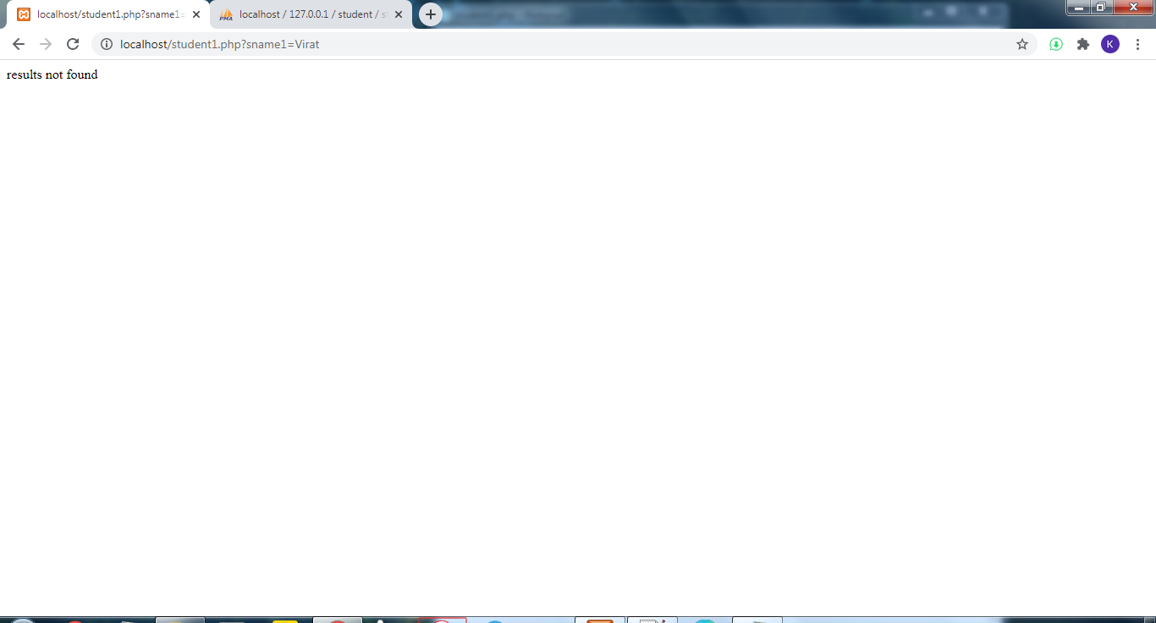

**10.**

Write Ruby programs for the following:

1. print multiplication table of a given number.
2. To count the number of words in a sentence.
3. To calculate the sum of all even number up to a given limit ‘n’.

**i)**

**r2.rb**

puts "Enter the number"

num=gets.chomp.to_i

for i in 1..10

mult=num*i

puts "#{num} * #{i} = #{mult}"

end

**Output:**

**Enter the number**

**4**

**4 * 1 = 4**

**4 * 2 = 8**

**4 * 3 = 12**

**4 * 4 = 16**

**4 * 5 = 20**

**4 * 6 = 24**

**4 * 7 = 28**

**4 * 8 = 32**

**4 * 9 = 36**

**4 * 10 = 40**

**ii)**

**r3.rb**

puts "Enter the sentence"

str=gets.chomp

i=0

count=1

len=str.length

while (i<len)

w=str[i].chr

if (w==' ')

count=count+1

end

i=i+1

end

puts "Number of words:#{count}"

**Output:**

**Enter the sentence**

**tr r rte**

**Number of words:3**

**iii)**

**r4.rb**

sum =0

puts "Enter n:-"

n=gets.chomp.to_i

i=1

while(i<=n)

if(i%2==0)

sum=sum+i

i=i+1

else

i=i+1

end

end

puts "The sum is #{sum}"

**Output:**

**Enter n:-**

**12**

**The sum is 42**